**Create two Ec2 servers and Configure Load Balancer using Terraform**

* Open Visual Studio code create

1. create vpc.tf
2. create igw.tf
3. create security group sg.tf
4. create 2 ec2 instance ec2.tf
5. create appache1.sh && create appache2.sh
6. create load balancer and target group
7. create output.tf

* All required .tf files are created

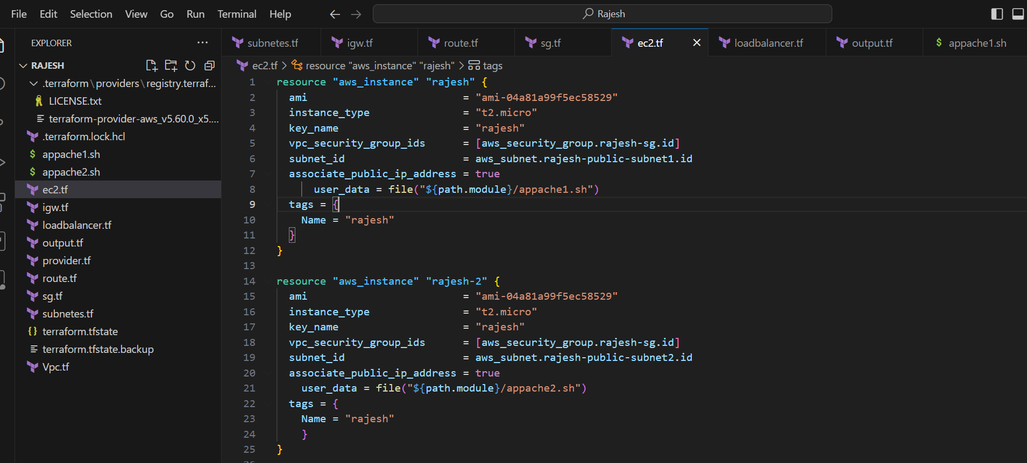

* Execute Terraform Init and terraform validate to check code validation

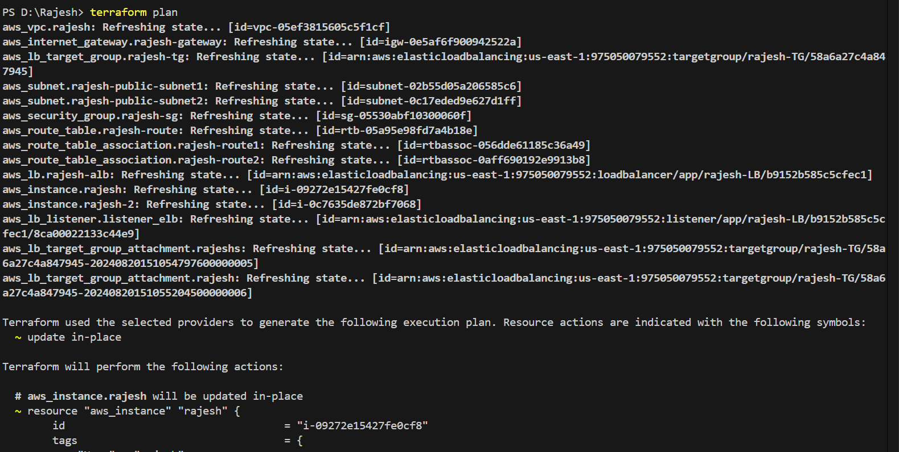

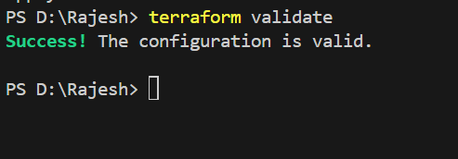

* After code validation run Terraform apply command to execute .tf files

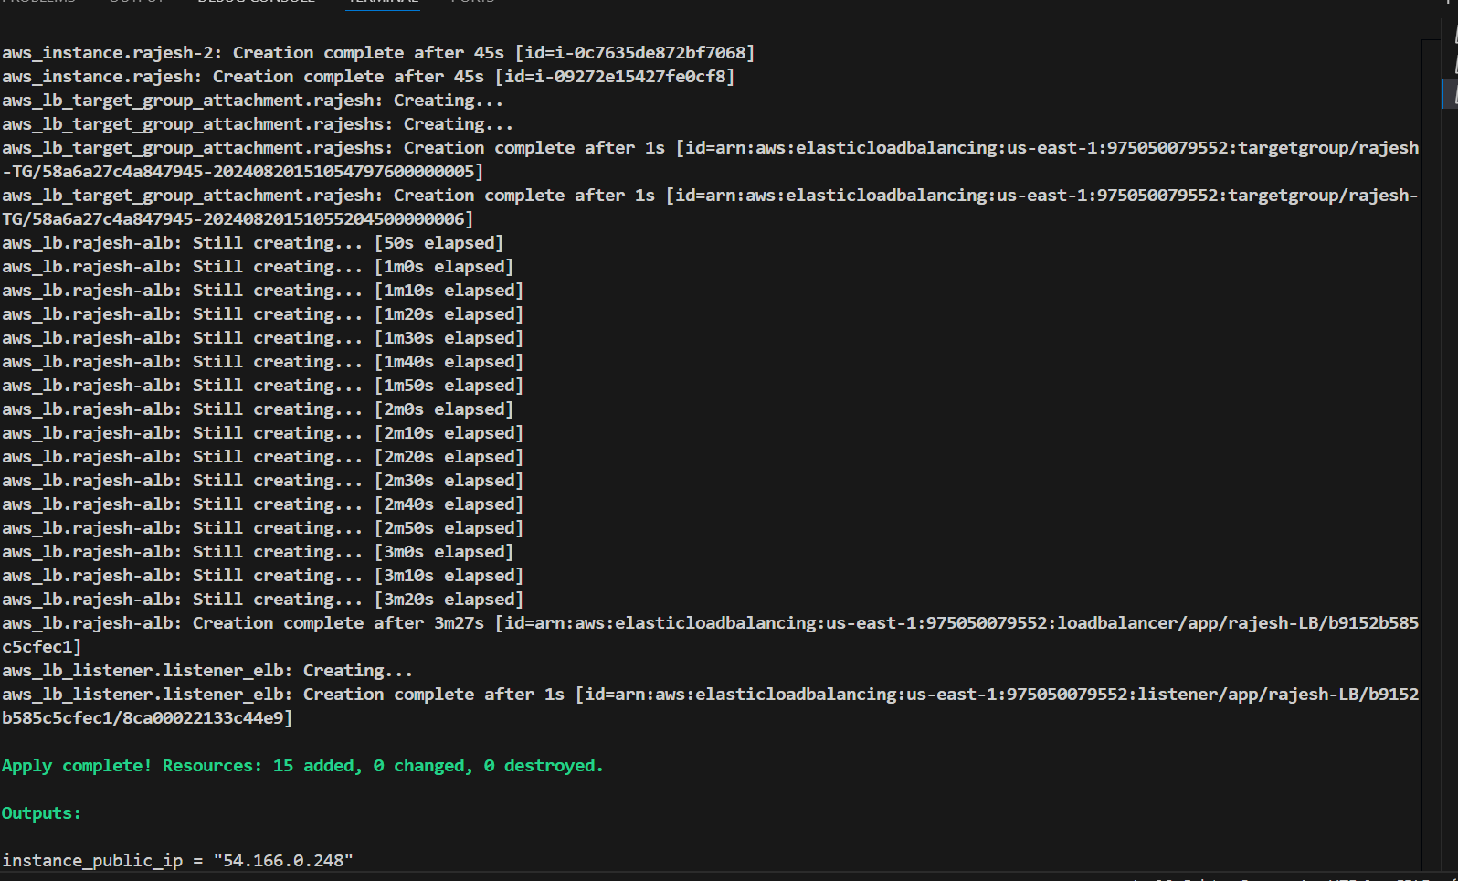

* Check the output in Amazon console
* 2 Ec2 servers are created

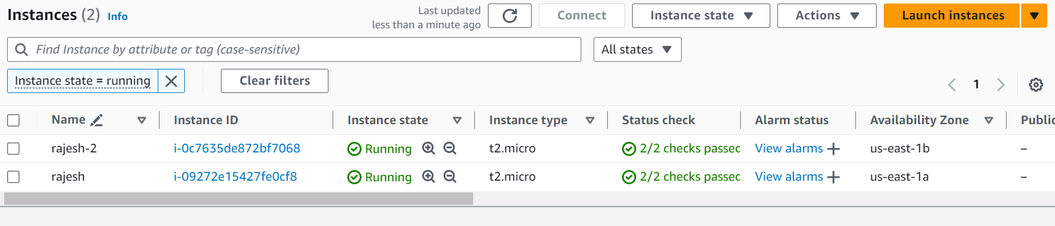

* VPC Created

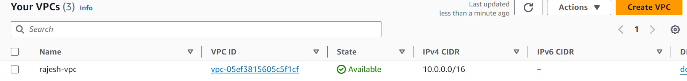

* 2 subnets are created

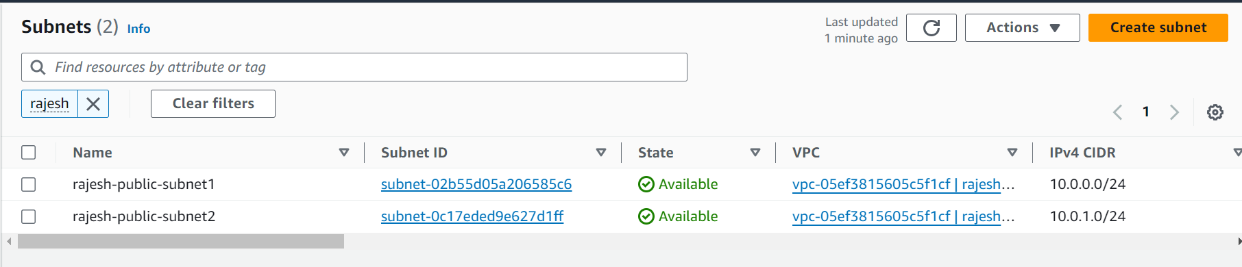

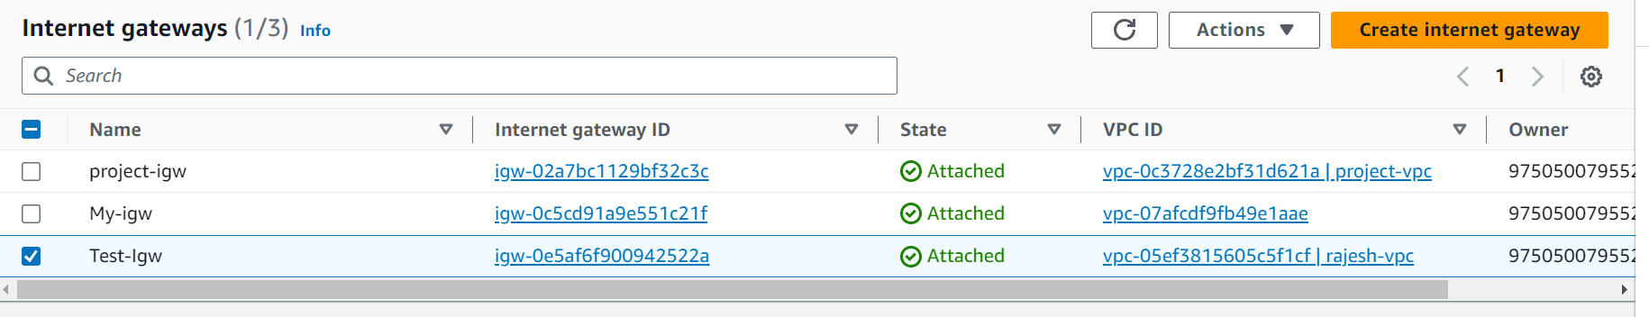

* Loadbalancer and target Group created

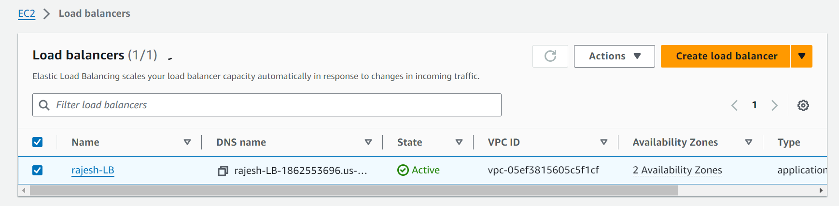

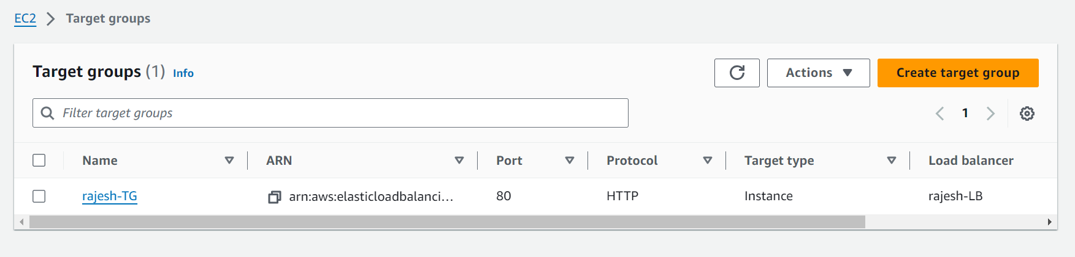

* Test the Webpage using loadbalancer DNS

